NETFLIX CLONE:

Npm init -y use this command to install package.json file.

npm install express jsonwebtoken mongoose cookie-parser dotenv axios bycript

express->web framwork

jsonwebtoken->for authentication

mongoose->mongo DB

cookie-parser->parse the incoming cookies

dotenv->env.file

axiox->http client(send request get some data)

bycript->hash the password

for frontend part

**cd frontend**

**npm create vite@latest .**

. represents current directory

press **y** as fronted folder is empty

then choose react and javascript

**npm i**

it will create node module and all necessary packages in it

**packages for frontend:**

**1.react hot toast package:**

its link is below:

[**react-hot-toast - The Best React Notifications in Town**](https://react-hot-toast.com/)

**2.lucid react:**

for icons we use this package and its link is below

[**Lucide React | Lucide**](https://lucide.dev/guide/packages/lucide-react)

[**Lucide**](https://lucide.dev/icons/)

**3.react player**

for grabbing youtube videos

[**react-player - npm**](https://www.npmjs.com/package/react-player)

so for all above packages to be installed in our project write this code on terminal of your project

**npm i axios lucide-react react-player react-hot-toast react-router-dom zustand**

**react-router-dom** used to navigate between different pages

**zustand->**

**to start react server:**

npm run dev

tailwind with vite use ki ha

**click on logo to move to some page :**

**<Link to="/">**

**<img src="/netflix-logo.png" alt="Logo" className="w-52"/>**

**</Link>**

**Already have an account? <Link to={"/login"} className="text-red-500 hover:underline">Sign in</Link>**

This is example for it …

Way to add opacity :**bg-black/60**

**To click on Email label we can do that like this it will happen like this ka email label per click karo ga tu wo input ki jagha per click hojai ga and you can enter easily…**

htmlFor="email"

ager hum **don,t** likhta hain ya koi bhi asa kew use karain jo use karna per error da rahi ho tu hum eslint.js file ma jaker rules ma ya likhlo

**"react/no-unescaped-entities":"off",**

**Flex-1** aik tarhan ki width da ga left container or right container ko

**<Chevron/>**

Aik component ha lucit react ka jo symbol data ha ya wala >

ya separator ha jo line nhi lagi hoti do containers ka darmiyan wo wali……

    <div className="h-2 w-full bg-[#232323]" aria-hidden='true' />

**Ager image ka oper overlay lagana ho to ya karolo:**

<div className="relative h-screen text-white ">

      <Navbar/>

      <img src="/extraction.jpg" alt="hero img" className="absolute top-0 w-full h-full object-cover -z-50"/>

      <div className="absolute top-0 left-0 w-full h-full bg-black/50 -z-50"></div>

    </div>

**Ager FAQS likhna hon tu ya karlo:**

import  { useState } from "react";

const FAQS = () => {

  const [openFAQ, setOpenFAQ] = useState(null); // Track which FAQ is open

  const faqs = [

    {

      question: "What is Netflix?",

      answer:

        "Netflix is a streaming service that offers a wide variety of award-winning TV shows, movies, anime, documentaries, and more on thousands of internet-connected devices.You can watch as much as you want, whenever you want without a single commercial – all for one low monthly price. There's always something new to discover and new TV shows and movies are added every week!",

    },

    {

      question: "How much does Netflix cost?",

      answer:

        "Watch Netflix on your smartphone, tablet, Smart TV, laptop, or streaming device, all for one fixed monthly fee. Plans range from Rs 250 to Rs 1,100 a month. No extra costs, no contracts.",

    },

    {

      question: "Where can I watch?",

      answer:

        "Watch anywhere, anytime. Sign in with your Netflix account to watch instantly on the web at netflix.com from your personal computer or on any internet-connected device that offers the Netflix app, including smart TVs, smartphones, tablets, streaming media players and game consoles.You can also download your favorite shows with the iOS or Android app. Use downloads to watch while you're on the go and without an internet connection. Take Netflix with you anywhere.",

    },

    {

      question: "How do I cancel?",

      answer:

      "Netflix is flexible. There are no pesky contracts and no commitments. You can easily cancel your account online in two clicks. There are no cancellation fees – start or stop your account anytime..",

    },

  ];

  const toggleFAQ = (index) => {

    setOpenFAQ(openFAQ === index ? null : index); // Open/close the FAQ

  };

  return (

    <div className="w-full bg-black text-white py-10">

      <div className="max-w-5xl mx-auto px-4">

        <h2 className="text-3xl font-bold text-center mb-6">

          Frequently Asked Questions

        </h2>

        <div className="space-y-4">

          {faqs.map((faq, index) => (

            <div

              key={index}

              className="border border-gray-700 rounded-md overflow-hidden"

            >

              <button

                onClick={() => toggleFAQ(index)}

                className="w-full flex justify-between items-center p-4 bg-gray-800 hover:bg-gray-700"

              >

                <span>{faq.question}</span>

                <span className="text-xl">

                  {openFAQ === index ? "X" : "+"}

                </span>

              </button>

              {openFAQ === index && (

                <div className="p-4 bg-gray-900 border-t border-gray-700">

                  {faq.answer}

                </div>

              )}

            </div>

          ))}

        </div>

      </div>

    </div>

  );

};

export default FAQS;

**to have effect like this from top to bottom ka top per Zaida black araha hatu ya karo:**

 <div className="bg-gradient-to-b from-black via-transparent to-transparent absolute w-full h-full top-0 left-0 -z-10"></div>

              <Play className="size-6 inline-block mr-2 fill-black"/>

Use fill-black property to color the play button

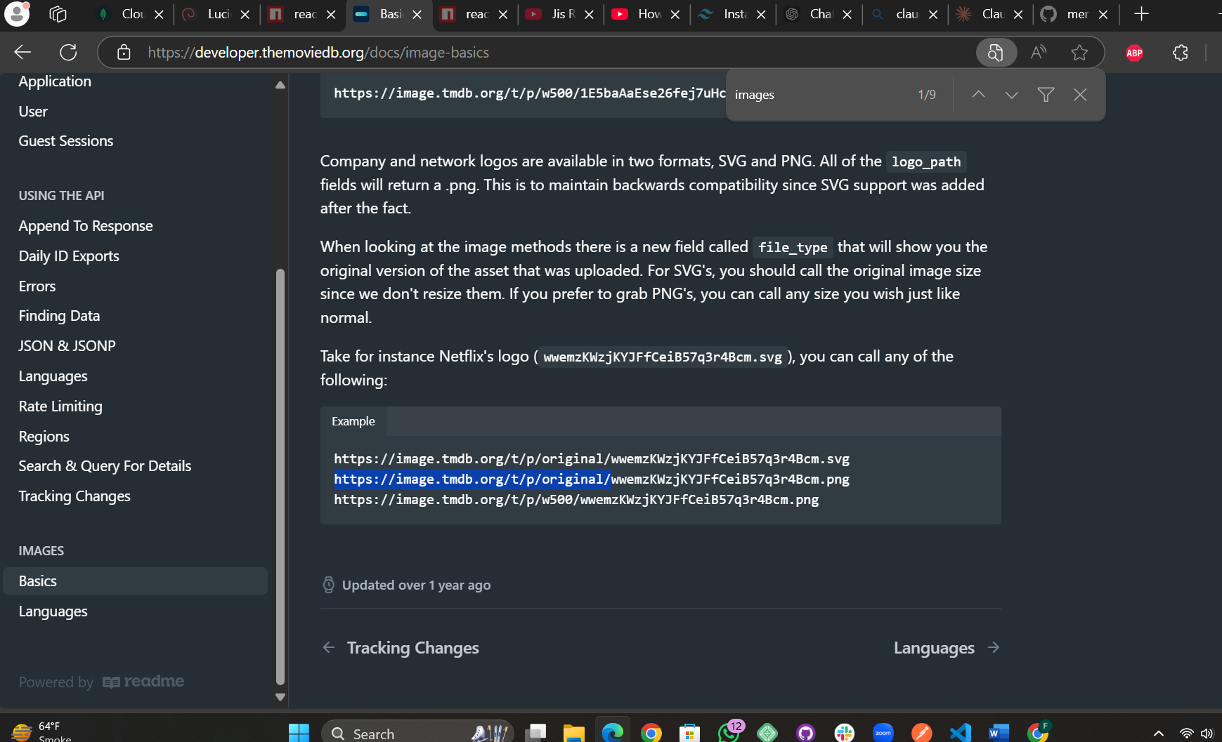

Image hover per image ka zoom hona

<div className="flex space-x-4">

        {content.map((item)=>(

            <Link to={`/watch/${item.id}`} className="min-w-[250px] relative **group**" key={item.id}>

                <div className="rounded-lg overflow-hidden">

                    <img src={SMALL_IMG_BASE_URL+item.backdrop_path} alt={item.title} className="**transition-transform duration-300 ease-in-out group-hover:scale-125**"/>

                </div> </Link>))} </div>

Buttons for slider

Ya packeage ha jis ka zariya scroll bar hide hojai gi jo is property(scroll-x-overflow }sa ati ha is ka liya ap nicha wali command ko frontend folder ka terminalper run karo or phir tailwind config file ma jeker import wali line likho or phir us div ka jo slider bani ha usko class do **slidebar-hide** ka name sa

**npm install tailwind-scrollbar-hide**

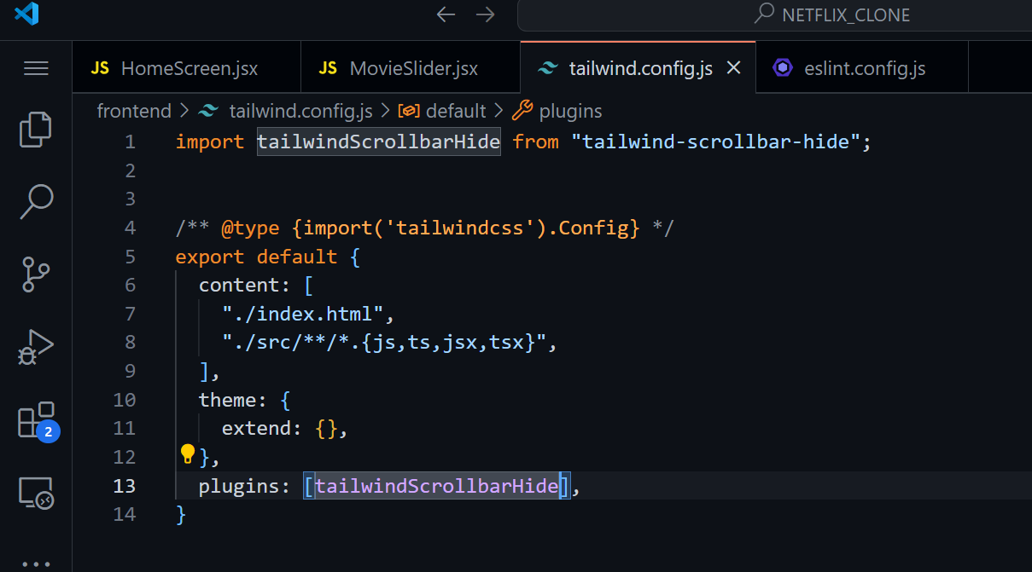

**Shimmer aik loading page ka ha ager add karna ho tu karlo….**

**.shimmer{**

**animation:shimmer 2s infinite linear;**

**background:linear-gradient(to right,#2c2c2c 4%, #333 25%, #2c2c2c 36%);**

**background-size:1000px 100%;**

**}**

**@keyframes shimmer{**

**0%{**

**background-position:-1000px 0;**

**}**

**100%{**

**background-position: 1000px 0;**

**}**

**}**

Loader in page:

<div className="flex justify-center itmes-center bg-black h-full">

        <Loader className="animate-spin text-red-600 size-10"/>

        </div>

